**Case Study – 3  
(25 points)**

**Name: Patrick Woodrum**

**Clemson ID: C79975506**

**Submission**: Save this Word document with your answers as a PDF file and upload the PDF file to Canvas.

(5 pts) Build a risk management analysis for the Book Exchange Project (Fig 3.26) with at least 5 risk items, estimating likelihood and impact. This is easier to do after you complete the Work Breakdown Structure and Gannt chart below.

(20 pts) Create a work breakdown structure and Gantt chart for the Book Exchange Project. Your WBS should have at least 10 main tasks and at least 2 sub-tasks for each one (for a total of 20 tasks). Construct your Gannt chart (using the same tool as before) such that:

* All of the tasks and subtasks from your WBS make it into the project
* Assign durations to each of the tasks
* Use the January 1 of this year as the start date for your plan
* Create the appropriate dependencies between your tasks and subtasks

Use one of the project management tools identified on the “External Tools Page” in Canvas.

Identify the critical path for your project (by task IDs):

Create a PDF of your Gantt Chart

Submit your Risk Management plan & the PDF of your Gantt Chart to Canvas

WORK BREAKDOWN STRUCTURE:

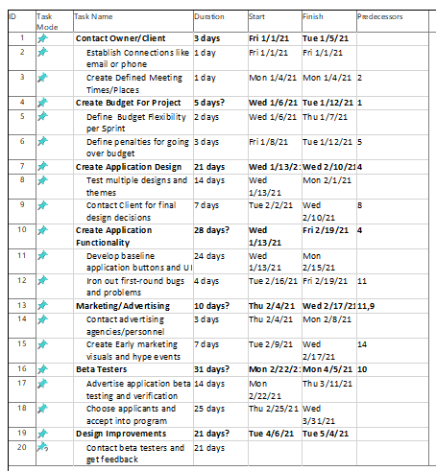

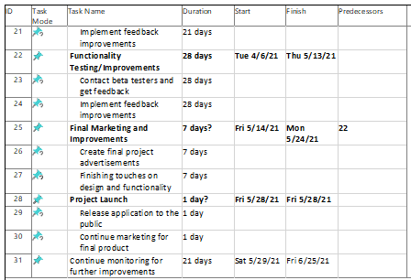

Critical Path by ID: 1, 4, 10, 16, 22, 25, 28, 31

GANTT CHART –

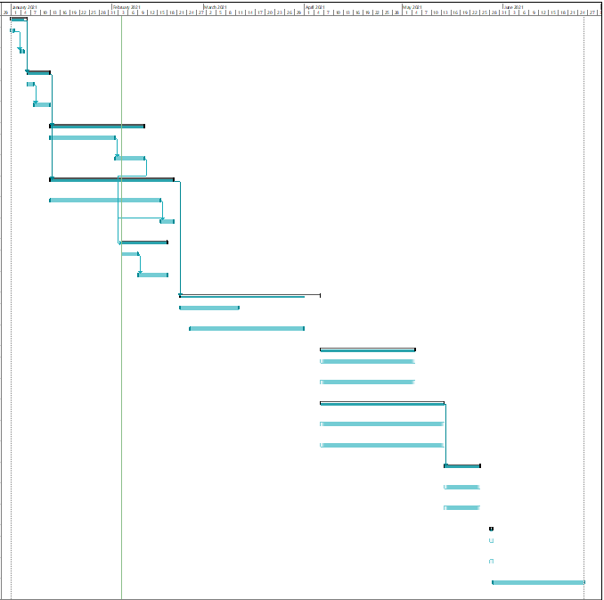

Risk Plan –

